**Database Systems**

**Assignment #2**

**Name: Rabia Batool**

**Registration #: 2021-CE-04**

**Department: Computer Engineering**

# **Question 1:**

Draw an Enhanced Entity Relationship (EER) Diagram for the following specifications.

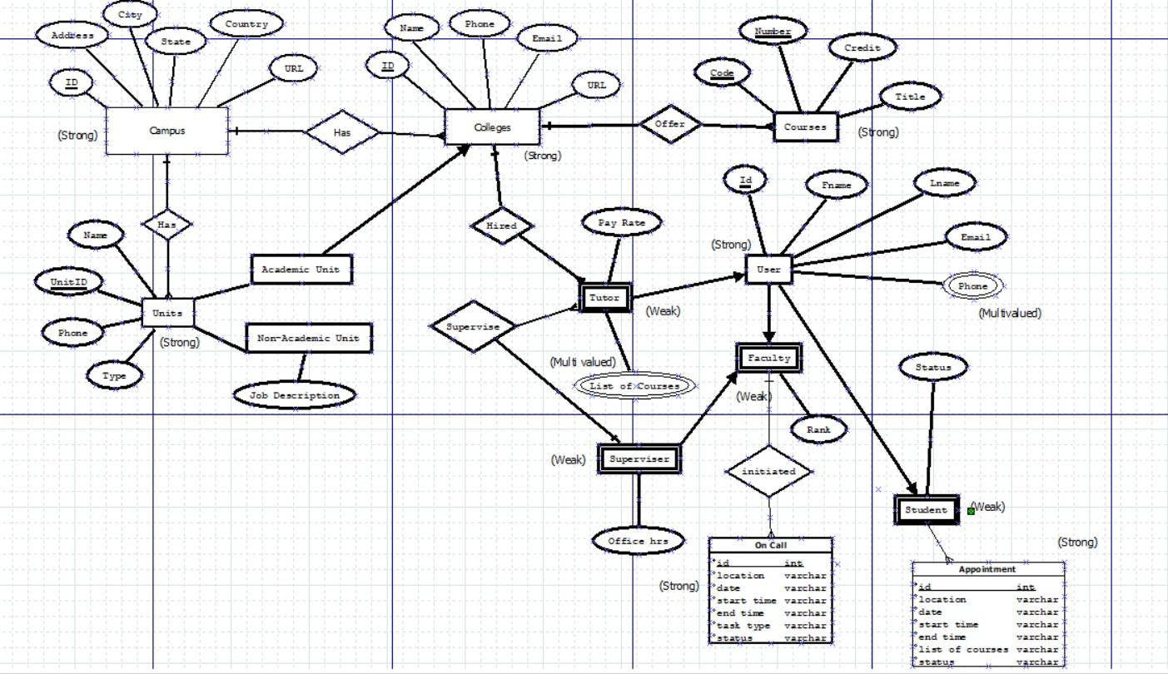

**Entities:**

**Campus(Strong Entity):**

* **Attributes**(ID,Address,City,State,Country,URL)
* **Relation(**Has many Colleges (1, N), Has many Units (1, N))
* **Primary Key**(Id)

**Units(Strong Entity):**

* **Attributes**(UnitId,Nmae,Phone,Type(Academic and non Academic))
* **Relation(**Belongs to a Campus (N, 1), Associated with a College (if Academic) (0, 1), Has a Job Description (if Non-Academic) (0, 1))
* **Primary Key**(UnitId)

**Course(Strong Entity):**

* **Attributes(Code,Number,Credit,Title)**
* **Relation(**Offered by a College (N, 1))
* **Primary Key**(Code,Number)

**College(Strong Entity):**

* **Attributes**(Id,Name,Phone,Email,URL)
* **Relation(**Belongs to a Campus (N, 1),Offer Courses(1,N)**)**
* **Primary Key**(CollegeId)

**Tutor(Weak Entity):**

* **Attributes**(Pay Rate,List of Courses)
* **Relation**(Hired By College(1,N),Supervised by superviser(1,N))
* **Multivalued Attribute**(List of Courses)

**Superviser(Weak Entity):**

* **Attribute**(Office Hours)
* **Relation**(Supervised tutors(1,N),is A faculty(1,1)

**User(Strong Entity):**

* **Attribute(id,Fname,Lname,Email,Phone)**
* **Relation(**Can be Faculty or Student (0, 1) for each type ,Can be Tutor(0,1))
* **Multivalued Attribute(Phone)**
* **Primary Key(id)**

**Faculty(Weak Entity)**

* **Attribute**(Rank)
* **Relation**(initiates oncall)

**Student(Weak Entity):**

* **Attribute(Status)**
* **Relation**(has many apponitments(1,N))

**On Call(Strong Entity):**

* **Attribute**(id,location,date,start time,end time,status,task type ,status)
* **Primary Key**(id)
* **Relation**(Initiated by Faculty (N, 1))

**Appointment(Strong Entity)**

* **Attribute(id,location,date,start time ,end time ,list of courses,status)**
* **Primary Key(id)**
* **Relation**(Scheduled between a Tutor and a Student (N, 1))

# **Question 2:**

Draw an ER diagram that would be mapped into the following relational database schema:

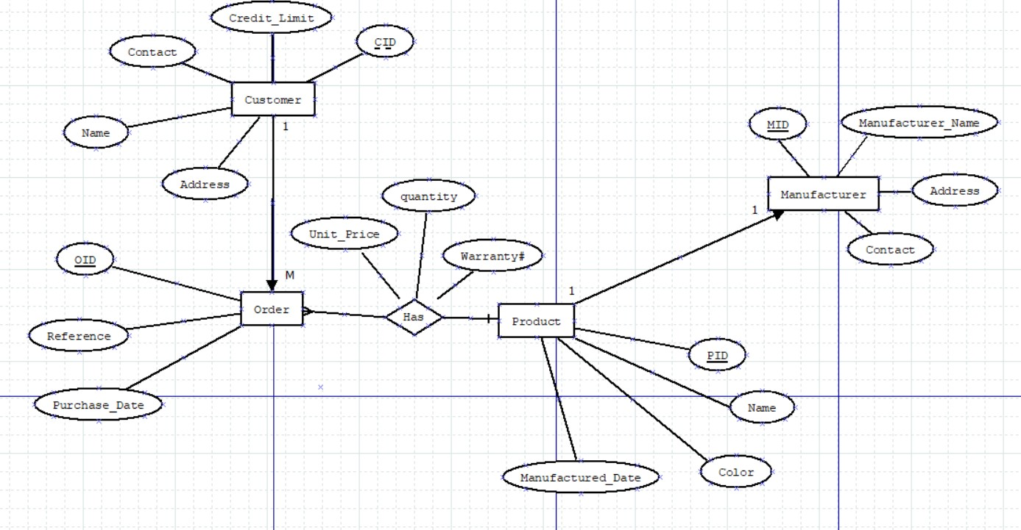

# **Question 3:**

Consider the following ER diagram. Assume that an employee may work in up to two departments or may not be assigned to any department. Assume that each department must have one and may have up to three phone numbers.

Assume the following additional system requirements:

* Each department can have anywhere between 1 and 30 employees.
* Each phone is used by one, and only one, department.
* Each phone is assigned to at least one and may be assigned to up to 30 employees.
* Each employee is assigned at least one, but no more than 5 phones.

1. Supply (min, max) constraints on this diagram. State clearly any additional assumptions you make.
2. Under what conditions would the relationship HAS PHONE been redundant in this example?

Solution (a):

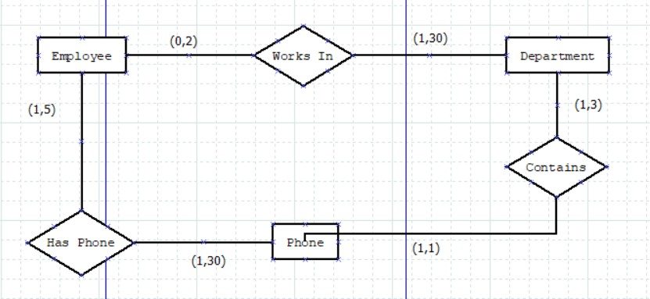

**Assumptions:**

* Each Employee must be assigned at least one phone.
* An Employee can be assigned up to 5 phones.
* Each Phone is assigned to at least one Employee

1. The relationship "HAS PHONE" would be redundant if the following conditions were met:

If we assume that each Department can have only one phone (1,1), and each phone is used by one Department (1,1), then the "HAS PHONE" relationship becomes redundant because the direct relationship between Department and Phone would already represent the same information.